Process Book

* **Overview and Motivation:** Provide an overview of the project goals and the motivation for it. Consider that this will be read by people who did not see your project proposal.
* **Related Work:** Anything that inspired you, such as a paper, a web site, visualizations we discussed in class, etc.
* **Questions:** What questions are you trying to answer? How did these questions evolve over the course of the project? What new questions did you consider in the course of your analysis?
* **Data:** Source, scraping method, cleanup, etc.
* **Implementation:** Describe the intent and functionality of the visualizations you implemented. Provide clear and well-referenced images showing the key design and interaction elements
  + We implemented a year-based selection in which you can drag the endpoints of the rectangle to select a range of years and drag the rectangle itself to change the years within the range. This is so that we are able to choose based on more recent/older data. By updating the rectangle, the main scatterplot and additional plot is automatically updated.



* + Our main plot is a scatterplot. Each point represents a player. The colors are coordinated based off of the player’s positions: for example, blue represents a quarterback. The x-axis represents the increasing pick number of the players: meaning that the higher the pick (the “better” player in college football), the lower the x value. The y-axis represents the career approximate value, which is a standardized statistic based off of many career statistics. The higher a value, the better the player has performed in the NFL.

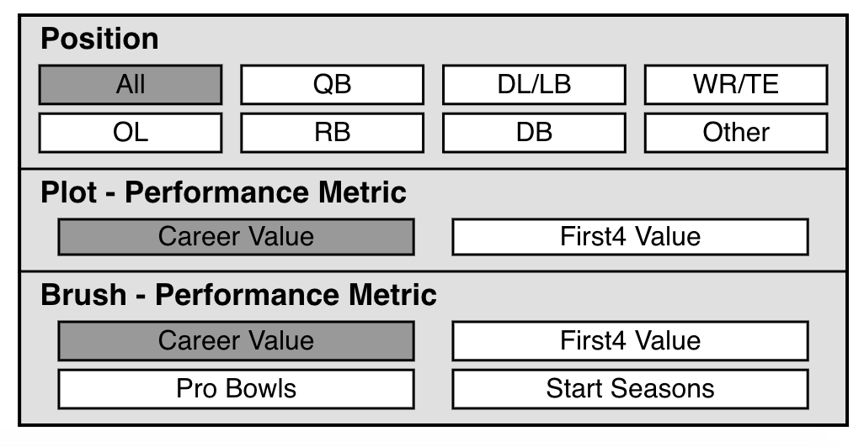

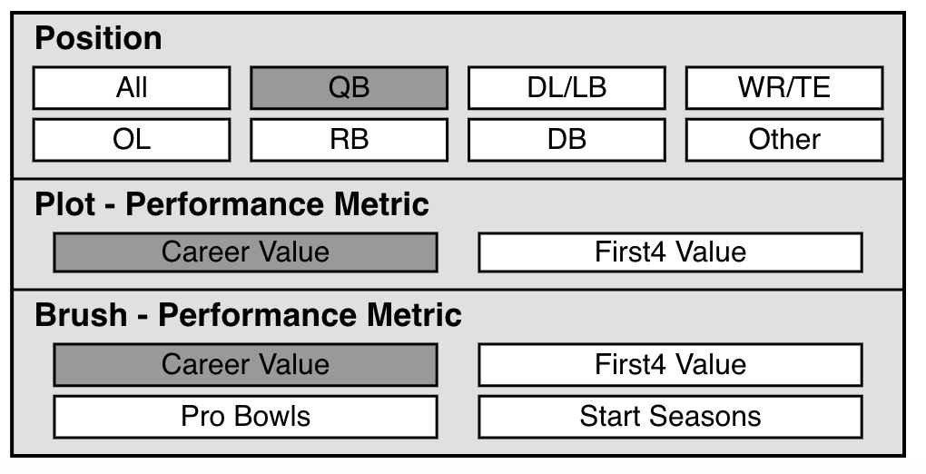

* + Our options box is one of our main interactive elements. You can click on any position and performance metric to choose what to look at in the main scatterplot.

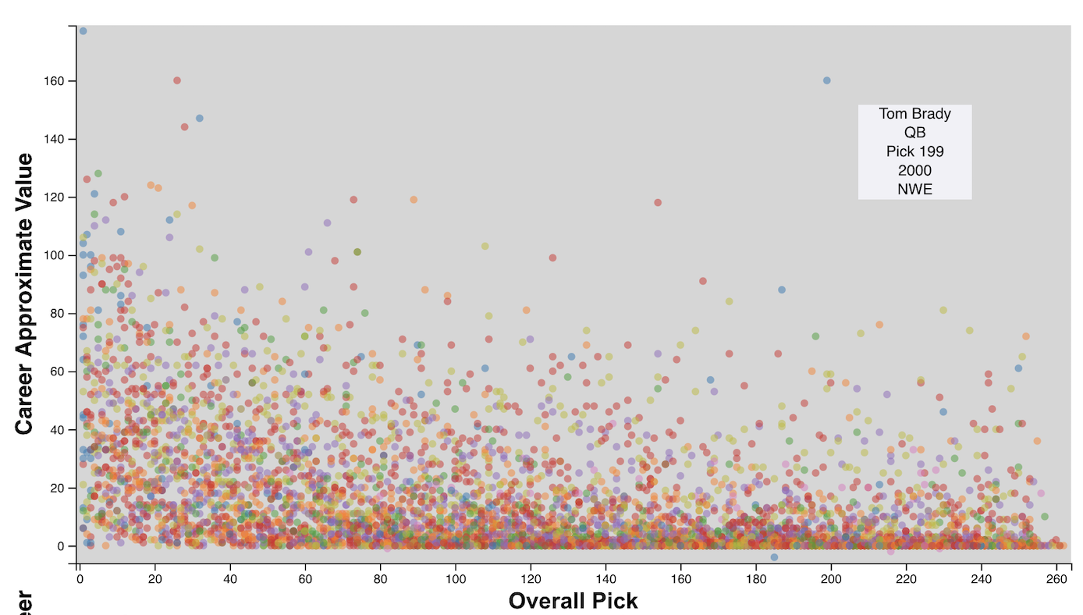

* + We are able to hover over a point to show the name, position, pick number, year, and team of that player. This is helpful to indicate what people may be outliers.
* **Exploratory Data Analysis:** What visualizations did you use to initially look at your data? What insights did you gain? How did these insights inform your design?
  + Initially, we made a single scatterplot relating Pick to Career Average. The plot was quite overwhelming and did not show a clear correlation between lower draft pick and higher career average. From this, we knew it would be important to show the data in separate views to see if there is a more realizable relationship between pick number and NFL success.
* **Design Evolution:** What were the different visualizations you considered? Justify the design decisions you made using the perceptual and design principles you learned in the course. Did you deviate from your proposal?
  + When we were looking at how to transition data when we were changing positions, at first, the interaction had all old points rising toward the top left point while fading out, whereas the new points were falling from the top left point while fading in. After discussion, we decided that it would be a less confusing transition to just have old points fade out and new points fade in.
  + We decided to use a double-headed slider for selecting by year. This tactic is useful for selecting a range of discrete entities.
  + We chose to have a second view that would be able to be modified by brushing that would show how a performance metric relates to a different NFL team for the set of points located within the brush. This is useful for providing some more context behind the data instead of just having our main view with all the different players
* **Analysis:** What did you learn about the data by using your visualizations? How did you answer your questions? How well does your visualization work, and how could you further improve it?